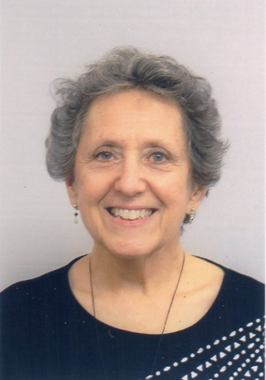Brenda Hancock learned the art of storytelling from listening to her mother’s recounting her French Resistance missions and her American grandmother’s relating her memories of “the time. . .” followed by stories of fish raining from the sky or mad dogs chasing them as her grandfather wildly drove the horse and buggy to a distant neighbor in need of help during childbirth, among many other captivating tales. Her first published work was *One of the Lucky Ones*, her mother’s biography that recorded for posterity those wonderful stories of survival and courage. Next came *Talent Luck Courage*, which intertwined her mother’s stories with those of her uncle, Robert Clary (LeBeau in “Hogan’s Heroes”), who survived four concentration camps and became the entertainer he always wanted to be. Her next two published works are novels based on her travels to France in *Mischievous Matchmakers* and Korea in *Starting Over.* Her most recent novel *Little Sparrow* takes the personality and spirit of her aunt Hélène Widerman and extends her life beyond boarding Convoy 34 from Drancy, France to Auschwitz. After a 38-year career in education that took her from her home state of Texas to Korea, Missouri, Germany, and Arkansas, Brenda enjoys being creative in her Alabama home that she shares with her husband and two spoiled rotten little dogs.